**8b. Develop a Guestbook Application Using JPA.**

**MySql Queries:**

CREATE DATABASE GuestBook;

USE GuestBook;

CREATE TABLE GuestBook(

VisitorNo Int PRIMARY KEY AUTO_INCREMENT,

VisitorName varchar(50),

Message varchar(100),

MessageDate varchar(40));

**File Name: GuestBook.java**

package myApp;

import javax.persistence.Column;

import javax.persistence.Entity;

import javax.persistence.GeneratedValue;

import javax.persistence.GenerationType;

import javax.persistence.Id;

import javax.persistence.Table;

**@Entity**

**@Table(name = "guestbook.guestbook")** // The database and table names should match as follows

public class GuestBook {

**@Id**

**@GeneratedValue(strategy = GenerationType.IDENTITY)**

**@Column(name="VisitorNo", unique=true, updatable=false)**

**private Integer visitorNo;**

**@Column(name="VisitorName")**

**private String visitorName;**

**@Column(name="Message")**

**private String message;**

**@Column(name="MessageDate")**

**private String messageDate;**

**public GuestBook() {**

**}**

**public Integer getVisitorNo() {**

**return visitorNo;**

**}**

**public void setVisitorNo(Integer visitorNo) {**

**this.visitorNo = visitorNo;**

**}**

**public String getVisitorName() {**

**return visitorName;**

**}**

**public void setVisitorName(String visitorName) {**

**this.visitorName = visitorName;**

**}**

**public String getMessage() {**

**return message;**

**}**

**public void setMessage(String message) {**

**this.message = message;**

**}**

**public String getMessageDate() {**

**return messageDate;**

**}**

**public void setMessageDate(String messageDate) {**

**this.messageDate = messageDate;**

**}**

}

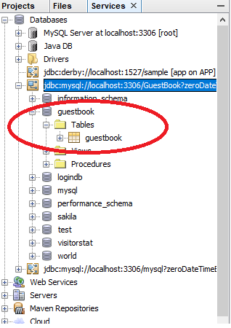

**Now perform the following steps**

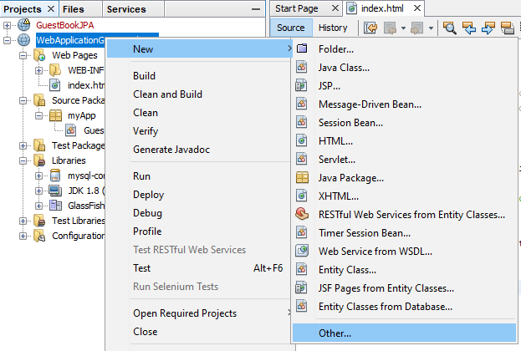

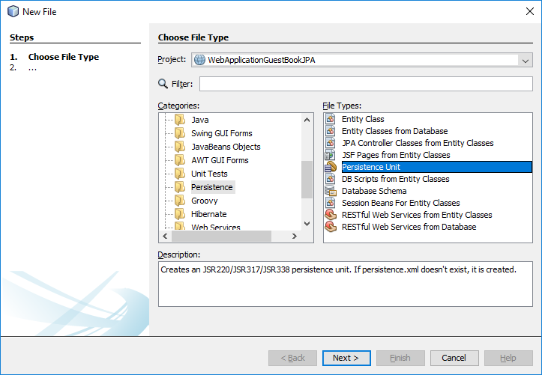

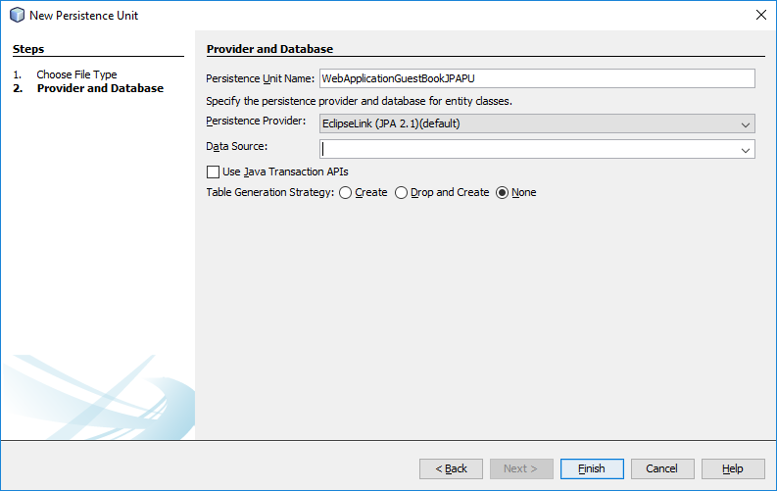

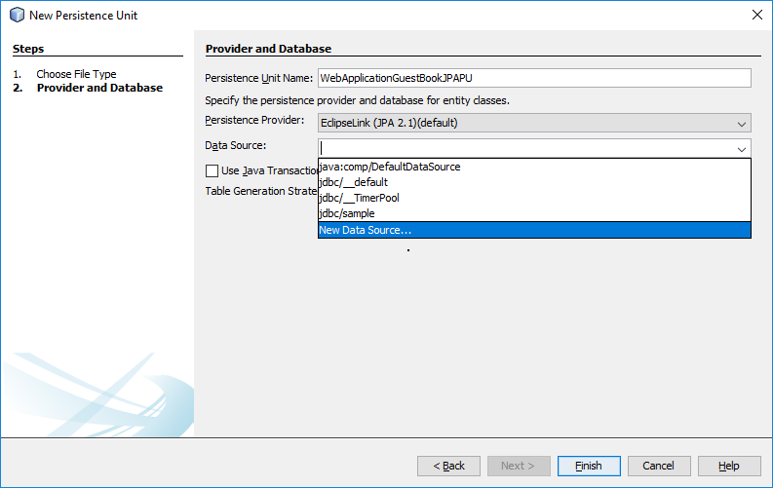

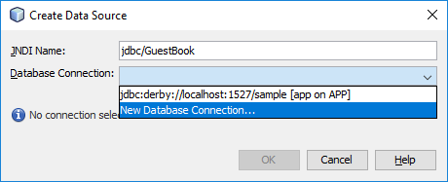

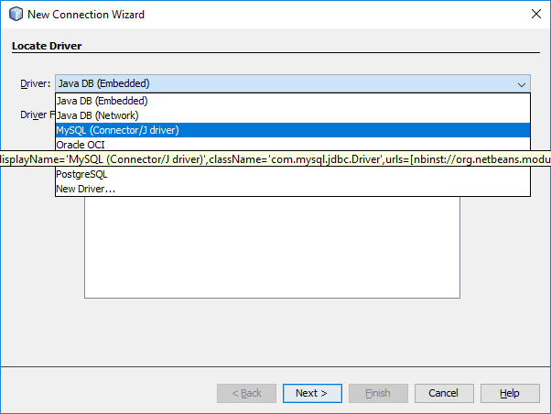

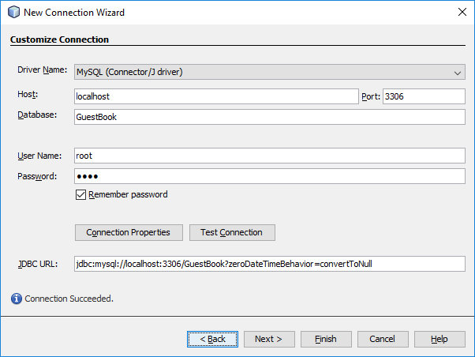

**Then Click “Finish”**

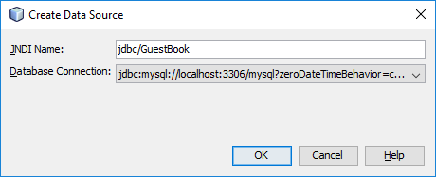

**Click “OK”**

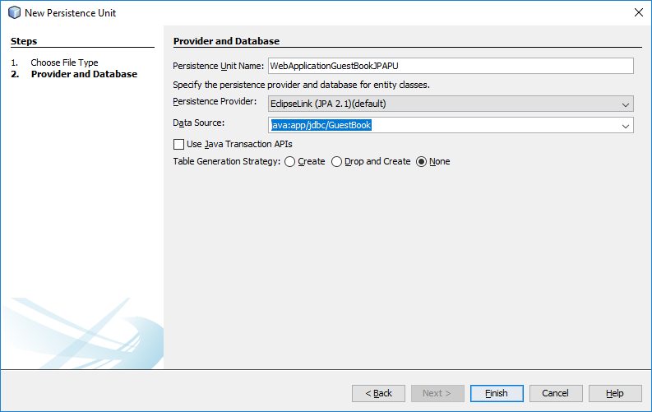

**Click “Finish”**

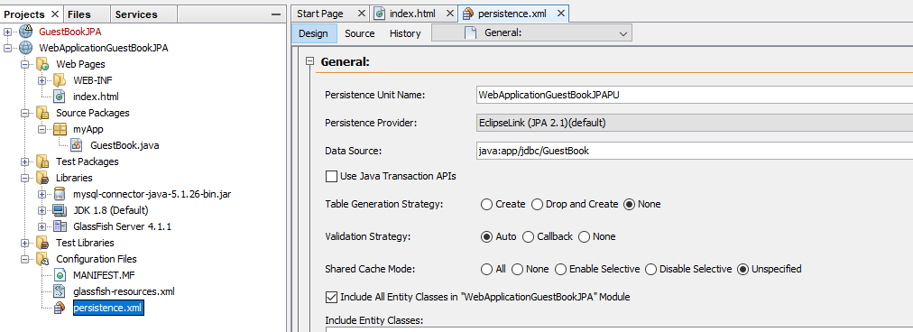

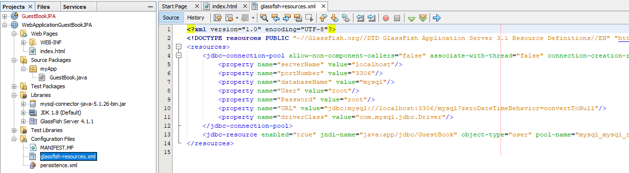

**File Name: index.jsp**

<%@page contentType="text/html" pageEncoding="UTF-8"%>

<!DOCTYPE html>

<html>

<head>

<meta http-equiv="Content-Type" content="text/html; charset=UTF-8">

<title>JSP Page</title>

</head>

<body>

**Sign the Guest Book**

**<form action="GuestBookView.jsp" method="post">**

**Visitor Name: <input type="text" name="guest" /> <br>**

**Message: <textarea rows="5" cols="36" name="message">**

**</textarea> <br>**

**<input type="submit" name="btnSubmit" value="Submit" />**

**</form>**

</body>

</html>

**File Name: GuestBookView.jsp**

<%@page import="myApp.GuestBook"%>

<%@page import="java.util.*"%>

<%@page import="javax.persistence.*"%>

<%@page contentType="text/html" pageEncoding="UTF-8"%>

<!DOCTYPE html>

**<%!**

**private EntityManagerFactory entityManagerFactory;**

**private EntityManager entityManager;**

**private EntityTransaction entityTransaction;**

**List<GuestBook> guestbook;**

**%>**

**<%**

**entityManagerFactory = Persistence.createEntityManagerFactory("WebApplicationGuestBookJPAPU");**

**entityManager = entityManagerFactory.createEntityManager();**

**String submit = request.getParameter("btnSubmit");**

**if (submit != null && ("Submit").equals(submit)) {**

**try {**

**String guest = request.getParameter("guest");**

**String message = request.getParameter("message");**

**String messageDate = new java.util.Date().toString();**

**GuestBook gb = new GuestBook();**

**gb.setVisitorName(guest);**

**gb.setMessage(message);**

**gb.setMessageDate(messageDate);**

**entityTransaction = entityManager.getTransaction();**

**entityTransaction.begin();**

**entityManager.persist(gb);**

**entityTransaction.commit();**

**} catch (RuntimeException e) {**

**if (entityTransaction != null) {**

**entityTransaction.rollback();**

**}**

**throw e;**

**}**

**response.sendRedirect("GuestBookView.jsp");**

**}**

**try {**

**guestbook = entityManager.createQuery("SELECT g from GuestBook g").getResultList();**

**} catch (RuntimeException e) {**

**throw e;**

**}**

**entityManager.close();**

**%>**

<html>

<head>

<meta http-equiv="Content-Type" content="text/html; charset=UTF-8">

<title>JSP Page</title>

</head>

**<body>**

**View the Guest Book <b>Click <a href="index.jsp"> here</a> to sign the guestbook.</b> <hr />**

**<%**

**Iterator iterator = guestbook.iterator();**

**while (iterator.hasNext()) {**

**GuestBook obj = (GuestBook) iterator.next();**

**%>**

**On**

**<%= obj.getMessageDate()%>,<br />**

**<b><%= obj.getVisitorName()%>:</b>**

**<%= obj.getMessage()%> <br /><br />**

**<% }%>**

**</body>**

</html>

**Output:**

1. **Biuld WebApplicationGuestBookJPA**
2. **Run the index.jsp file.**

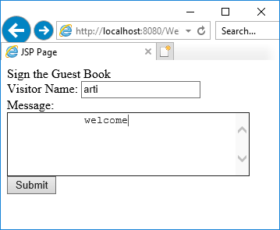 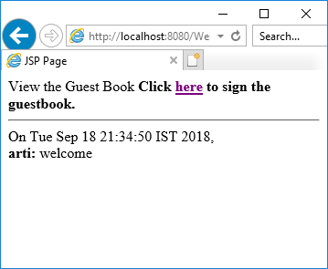

**mysql> select * from GuestBook;**

+-----------+-------------+---------------------+------------------------------+

| VisitorNo | VisitorName | Message | MessageDate |

+-----------+-------------+---------------------+------------------------------+

| 1 | arti | welcome | Tue Sep 18 21:34:50 IST 2018 |

+-----------+-------------+---------------------+------------------------------+